Title: | : Subsystem Design Description Template
References:
[1] | Software Requirements Specification  ABB EMF, Low Cost Water Waste & Industrial Transmitters
[2] | Overall Software Design Description  ABB EMF, Low Cost Water Waste & Industrial Transmitters
[3] | Digital Output Subsystem Software Requirements Specification  ABB EMF, Low Cost Water Waste & Industrial Transmitters
[4] | Digital Output Subsystem Use Case descriptions  ABB EMF, Low Cost Water Waste & Industrial Transmitters
[5] | Operating System  Segger embOS operating system  www.segger.com
Distribution | Software Archive
Author G. Horst Date: 2008.02.02

Approved Review Date:

Remarks:

Contents

1 Context 3
1.1 Overview 3
1.2 Pulse Output Concept 4
1.3 Use Case Diagram 6
1.4 Subsystem Definitions 7
1.5 Acronyms and Abbreviations 7
2 Data Sheet 8
3 Detailed Description 10
3.1 Static Modelling 10
3.2 Dynamic Modelling 12
3.3 Class Design 18
3.4 Detailed Design 19
3.5 Design Decisions and Limitations 23
3.5.1 Variant Handling 24
3.5.2 Pulse Output Timing Calculations 24
3.5.3 Pulse Operation Selection 25
3.5.4 Pulse Output Units-of-Measure Conversion Factors 25
3.5.5 Limit Frequency Dynamic Limits 26
3.5.6 Pulse Valid/Mode private attribute 26
3.5.7 Logic Signal Valid private attribute 26
3.6 Hardware Dependencies 27
3.7 Memory Usage 27
3.8 Data Object Description 30
Object Index (TDigitalOutput): 31
4 Revision Chart 33

List of Figures
Figure 1: Use Case Diagram for Digital Output Subsystem 6
Figure 2: Context Diagram for Digital Output Subsystem 10
Figure 3: Digital Output Subsystem Entity Diagram 11
Figure 4: Collaboration diagram for Set Logic Output 12
Figure 5 Collaboration diagram for Update Pulse Addition Count 13
Figure 6 Sequence diagram (extract) for Update Pulse Addition Count 14
Figure 8: Collaboration Diagram for Configure Digital Outputs 15
Figure 9: Digital Output subsystem class diagram 16
Figure 10: Activity diagram for Update Digital Output Actions 17
Figure 11: Activity diagram for Update Pulse Output ISR 18
Figure 12: Activity diagram for Pulse Width ISR 20
Figure 13: Parameter Tables for Configure Digital Outputs 21

Context
This Document is a representation of analysis, planning, implementation and decision-making. It consists of design information for the subsystem Digital Output subsystem. One of its major goals is to support reuse of the described subsystem.

The document is divided into two main parts. First there is the data sheet in chapter two. This chapter is intended for developers that want to reuse the subsystem. Therefore it lists important issues from a black-box view. The second chapter describes the design in more detail. This is the right place to look for developer that has to maintain or expand the subsystem.

Besides this document there are a couple of other documents that describe the requirements, test cases and the complete system the subsystem is used in. Links to those documents can be found at the end of the data sheet.

Overview
This document describes the functional design specification for the Digital Output subsystem IND Version of EMF flow meter project (see Common Software Requirements Specification [1] and project’s Overall Software Design Description [2]) of which there will be two main variants: Water / Wastewater (WW) and Industrial (IND).

The implementation of these requirements is split into two releases: A1 and A2. Current implementation level is A1. Items that are not scheduled for this release are shown in greyed-out text throughout this document.

The Digital Output subsystem, common to the IND variants provides up to 2 digital signals for output on dedicated hardware port-lines. The signal-source for these digital outputs is derived from a supplied configuration, typically from HMI or HART, or similar although can be any external user-interface. Briefly this can be a simple active low/high alarm, or in the case of Digital Outputs 1 and 2 only, it can be a pulse-train representing the current flow value in terms of a user selectable standard or the Totalizer unit.

The following table summarises the options available, and differences applicable:
Feature | Industrial Version
Number of HW Outputs | 2
HW Output Designation(s) | OP1 | OP2
Logic Output Configuration | Yes | Yes
Logic Output Simulation | Yes | Yes
Pulse Output Configuration | Yes | Yes
Pulse Output Simulation | Yes | Yes
Active Circuit Configuration | Yes | No

Pulse Output Concept

The Secondary Calculations subsystem passes flow-rate data to the Digital Output (2) subsystem (and separately to the Totalizer (1) subsystem). The Digital Output subsystem outputs a continuous pulse-train (4) of frequency proportional to the received flow-rate (2) value. This output is recalculated whenever an update is invoked.

Totalizer
Subsystem
Secondary Calculations
Subsystem
(1) flow-rate
(3) flow-total
HMI (Display)

Digital Output 1

Digital Output
Subsystem
(2) flow-rate

Digital Output 2
(4) frequency-output proportional to flow-rate, output as a
continuous pulse-train

Proposed Digital Output concept for this Design Solution

The detailed operation is described under the chapter 3.4.

Use Case Diagram
The following Use Case diagram illustrates the top-level uses derived in the Digital Output Subsystem Requirements Specification [3].

Figure 1: Use Case Diagram for Digital Output Subsystem
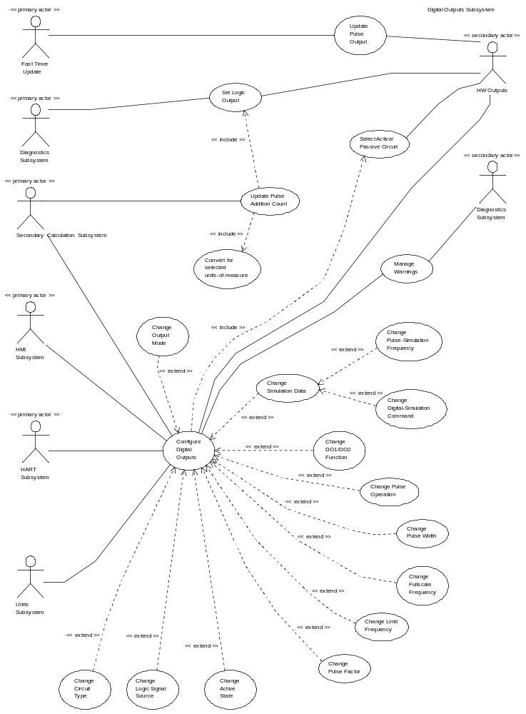

For use-case text descriptions, see Error: Reference source not found

Subsystem Definitions
Term | Definition
Diagnostic Subsystem | EMF subsystem responsible for handling error conditions and warnings, and also providing the General Logic signal status.
Digital Output Subsystem | EMF subsystem for providing output signals (eg for pulse output, flow direction indication, alarm/signal indication, etc.) to external hardware.
HART Subsystem | EMF subsystem responsible for interfacing to HART protocol communications.
HMI Subsystem | EMF subsystem providing HMI for local user access via display and key input.
Secondary Calculation Subsystem | EMF subsystem for providing/maintaining volume/mass flow information to local user and other subsystems.
NV-RAM Subsystem | EMF subsystem responsible for read / write access and maintenance of non-volatile memories (in transmitter and sensor).
Totalizer Subsystem | EMF subsystem for providing/maintaining flow volume/mass and flow direction information to local user and other subsystems.
Units Subsystem | EMF subsystem responsible for holding units-of-measure setting(s), and providing the necessary conversion factors for other subsystems.

Acronyms and Abbreviations
Term | Description
DO | Digital Output
EMF | Electro Magnetic Flowmeter
fwd | Forward
HART | Highway Addressable Remote Transducer
HMI | Human Machine Interface
HW | Hardware
ISR | Interrupt Service Routine
N/A | Not Applicable
NC | Normally Closed
NO | Normally Open
NV | Non-volatile
OP | Output
rvs | Reverse
TBD | To Be Determined
uot | Unit of Totalizer

Data Sheet
This chapter gives an overview about all important facts of the subsystem. It can be used by a developer who would like to reuse this subsystem.

Category | Item | Description
Development | Version / Status | Development complete
Development | Known Bugs | Not known
Development | Planned Improvements | None
HW-Platform | Type | M32C
HW-Platform | Clocking | 24MHz
SW-Development Environment | Compiler | M16C6x / M16C20 / R8C IAR C/EC++ Compiler Version 3.10a  M16C80 / M32C IAR C/EC++ Compiler Version 3.10a
SW-Development Environment | Operating System | Segger embOS for M16C6x / M16C20 / R8C version 3.20  Segger embOS for M16C80 / M32C version 3.24b
SW-Development Environment | Case / Code-Generation Tool | None
Required Resources | Operating System | None
Required Resources | HW | Hardware Timers:  - Frequency timer (Timer B2) is used for the generation of the base frequency used for pulse output  - Pulse count timer (Timer A0) is used to count the number of generated pulses and to trigger an underflow interrupt if the required number of pulses have been generated  - Pulse width timer for forward flow (Timer A4) is used to generate the correct mark length of the individual pulses  - Pulse width timer for reverse flow (Timer A1) is used to generate the correct mark length of the individual pulses  Two Port pins configured as:  (1) OP1 – logic output or pulse output (Pin 8.0);  (2) OP2 – logic output or pulse output (Pin 7.2);
Required Resources | RAM | Refer to section on Memory Usage. The breakdown is:  Diagnostic data: 4 Bytes  Configuration data: 10 Bytes  Private subsystem data: 35 Bytes  Total = 49 Bytes  Stack allocation for EXE and SRV methods:  UpdateEXE_DIGITALOUTPUT 75 Bytes  QmaxChangedEXE_DIGITALOUTPUT 39 Bytes  SystemUnitsChangedEXE_DIGITALOUTPUT 39 Bytes
Required Resources | NVRAM | Refer to section on Memory Usage:  DO Subsystem Configuration data: (3 x 3 =) 9 Bytes  Pulse-output specific configuration: 18 Bytes  Total = 27 Bytes
Required Resources | ROM | None
Required Resources | Execution Time
  Method Name | Min time | Max time | Average Time
  PulseUpdate ISR | TBD cycles | TBD cycles | N/A
  Execute | TBD | TBD | TBD
  GetAttribute | TBD | TBD | TBD
  PutAttribute | TBD | TBD | TBD
Required Resources | Special HW | 1x control port pin (OP1 HW passive/active selection)
Required Resources | Subsystems | 1.Secondary Calculations,  2.Units,  3.Diagnostics  4.Totalizer
Required Resources | Data Objects | 1.Qmax (from Secondary Calculations subsystem)  2.Units Conversion Factor (from Units subsystem)  3.Selected Unit from the Totalizer Subsystem  4.Alarm signal status (from Diagnostics subsystem)  5.Batch-fill complete status (from Totalizer subsystem)
Standards | Safety | None
Standards | Other | The Digital Output subsystem must not “lose” pulses, when integrated via an external counter, with respect to the internal-to-EMF Totalizer subsystem counter.
Documentation | Requirements / Use Cases | Requirement Specs:  Use Case templates:
Documentation | Public Interface Description | UpdateExe() method, called by the co-ordinator, in which the latest available flow value must be passed as a parameter;  SystemUnitsChangedExe() method, called by Totalizer, in which a change of user units-of-totalizer is indicated to this subsystem;  QmaxChangedExe() method, called by Secondary Calculations, in which a change of the system Qmax value is indicated to this subsystem;
Documentation | Test Specification | Test Documentation

Detailed Description

Static Modelling
Figure 2: Context Diagram for the Digital Output Subsystem

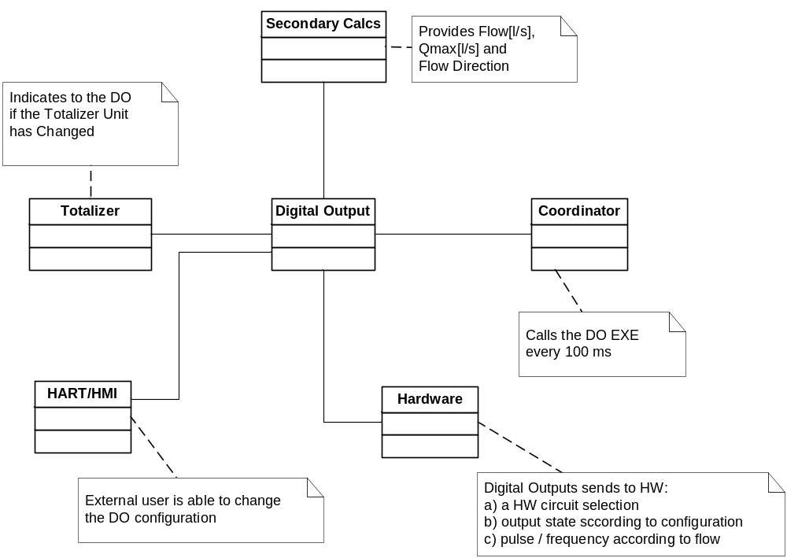

Figure 3: Digital Output Subsystem Entity Diagram
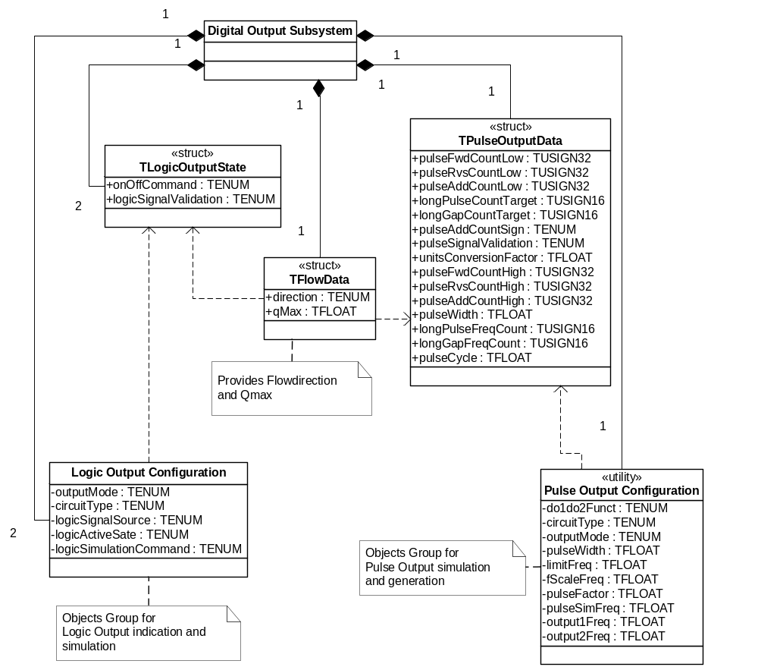

Dynamic Modelling

Figure 4: Collaboration diagram for Set Logic Output
This collaboration diagram represents the use-case Set Logic Output. There are 2 logic outputs. “Logic” in this context means any one of “General” (eg: diagnostic alarm), or “Fwd/Rvs”, or “Batch-fill complete” status signals. Execution in the sequence described, at the refresh-update-rate:

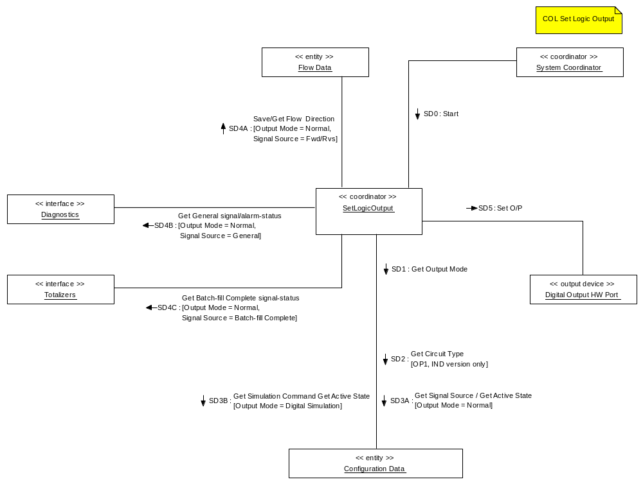

Figure 5 Collaboration diagram for Update Pulse Addition Count
This collaboration diagram represents the use-case Update Pulse Addition Count. Execution in the sequence described, at the refresh-update-rate:

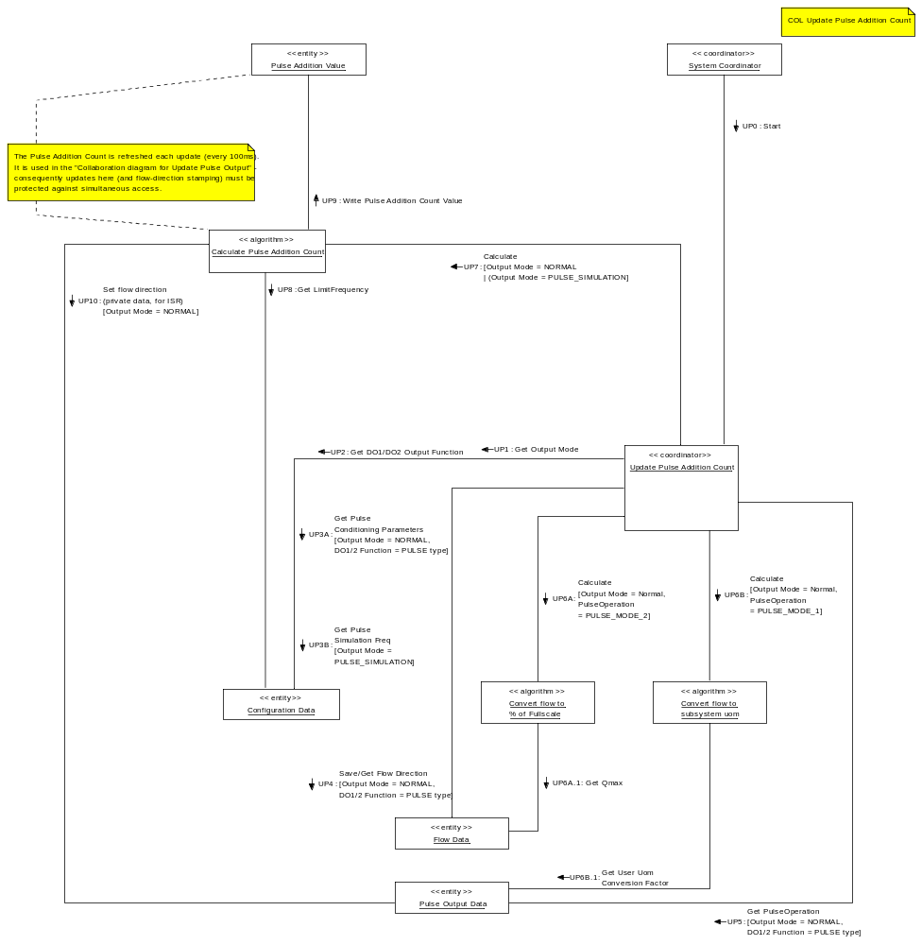

The collaboration involving the algorithm “Calculate Pulse Addition Count” requires further detailed explanation by way of the following sequence diagram:

Figure 6 Sequence diagram (extract) for Update Pulse Addition Count
This sequence diagram describes in more detail the sequence of operations to be followed during the most critical points of Update Pulse Addition Count.

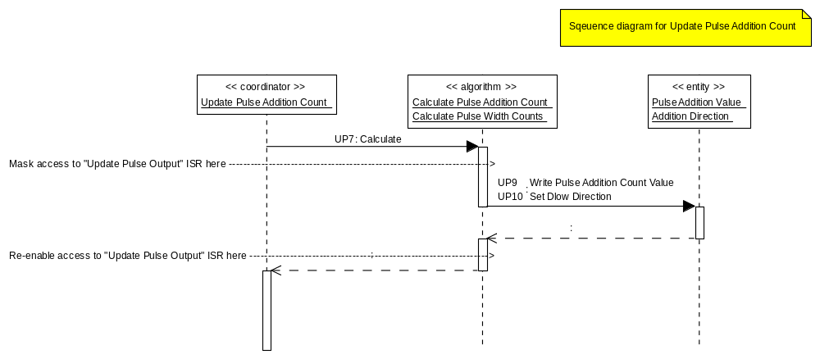

During the pulse-addition count update, it is important to consider correct procedure at the instance of a flow direction change. This is an issue where the configuration of the outputs allows forward-pulse on output OP1 and reverse pulse on OP2, or forward/reverse pulses on OP1 and a logic signal indicating direction on OP2.

In order to ensure correct operation, the sequence described here should be followed:
- The flow-value is passed into this subsystem on each update (this happens prior to the above sequence extract). The pulse addition count is calculated from the flow-value.
- The interrupt service routine (ISR) “Update Pulse Outputs” is inhibited.
- The calculated pulse addition count is saved for future output within the ISR.
- The flow-direction is saved (private, safe copy) for future checking within the ISR.
- The interrupt service routine is re-enabled.
Figure 7: Collaboration Diagram for Configure Digital Outputs

This collaboration diagram is a consolidation of all the included use-cases to Configure Digital Outputs, including “Manage Warnings”. In addition, the entry-points for Units (signalling change to user-units of measure) and Secondary Calculations (signalling change to Qmax value) are shown; these two items do not appear on the use-case diagram as they are merely informative, that is, the Digital Outputs subsystem responds to these be accessing methods of the subsystems concerned to obtain “units-of-totalizer” or “Qmax” as and when a change of value is signalled.
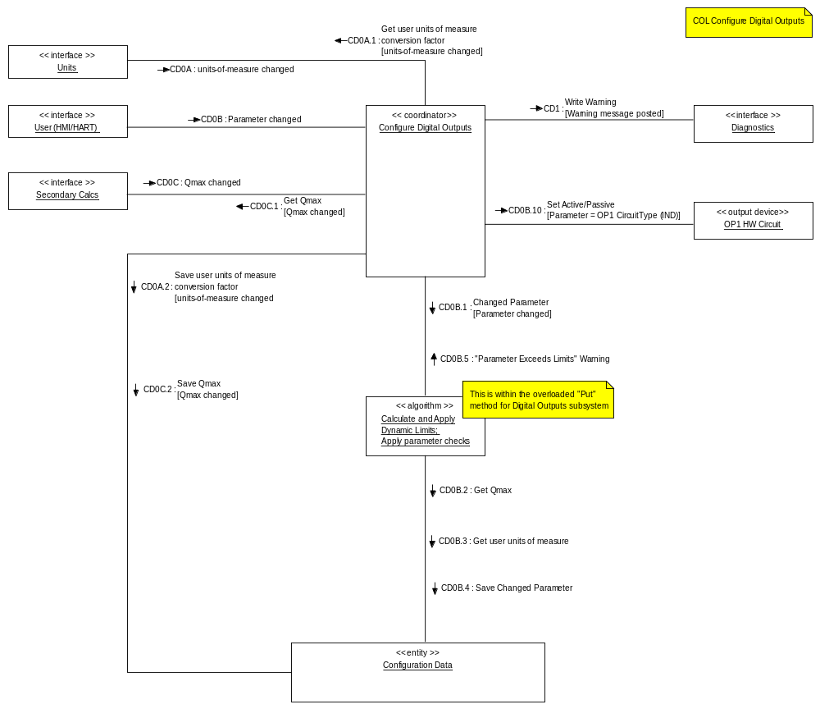

To better illustrate the “Configure Digital Outputs” use-case, a table of parameter versus effect has been produced (see figure 13).

Figure 9: Activity diagram for Update Digital Output Actions
It is possible at this stage to consolidate the collaboration of the main-thread “action” use-cases. Therefore this diagram depicts the activities within the Set Logic Output and Update Pulse Addition Count co-ordinator objects. The sequences from the two collaboration diagrams are mapped to this diagram for clarity:

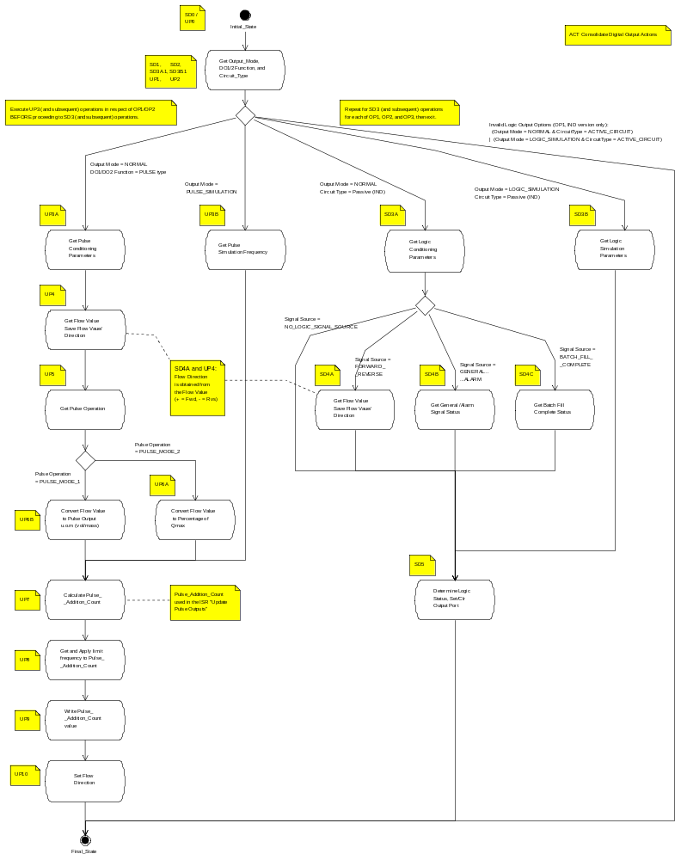

Class Design

The object-oriented design approach implies that object method calls include the address of the object’s data structure. This has not been shown in the diagrams although the C implementation requires the address to be supplied manually. The parameter for this is referred to as the “me” pointer.
eg
TUSIGN16 Get_T_UNIT (const T_UNIT SLOW *me, TUSIGN16 objectIndex,
TINT16 attributeIndex, void FAST *ptrValue);

Figure 8: Digital Output subsystem class diagram
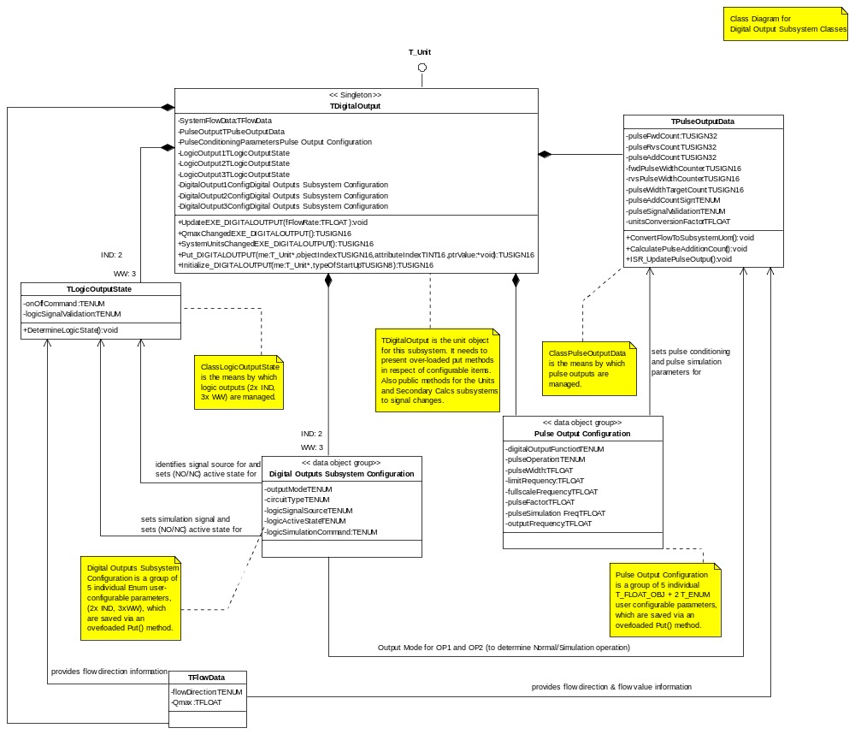

T_DIGITAL_OUTPUT class
This is the main subsystem class that supports the Common Framework T_Unit interface. The primary execute method is to update the Volume Flow [l/s] and the digital outputs refers to the Digital Output configuration.

Subsystem Access Methods

TUSIGN16 UpdateEXE_DIGITALOUTPUT (TFLOAT flowRate)
Updates the incoming flowRate in base units [l/s] on the digital Outputs or represent alarm states.

TUSIGN16 SystemUnitsChangedEXE_ DIGITALOUTPUT (void)
Called by the Totalizer Subsystem to advise the change of the Totalizer unit.

TUSIGN16 QmaxChangedEXE_ DIGITALOUTPUT (void)
Called by the Secondary Calculation Subsystem to advise the change of the Qmax value.

TUSIGN16 SetAlarmEXE_ DIGITALOUTPUT (TUSIGN16 alarmState)
Called by Diagnosis to present the alarm state.

TPulseOutputData class
The internal class is a singleton instantiated. It provides attributes which are required to handle the pulse output generation. The following attributes are defined within this class:

TUSIGN32 pulseFwdCountLow; // (1) forward roll-over count (lower 32 bit)
TUSIGN32 pulseRvsCountLow; // (2) reverse roll-over count (lower 32 bit)
TUSIGN32 pulseAddCountLow; // (3) value added to (1) or (2) each Update ISR (lower 32 bit)
TUSIGN16 longPulseCountTarget; // (4) value to be loaded for pulse > 50ms (for long pulse)
TUSIGN16 longGapCountTarget; // (5) value to be loaded for pulse > 50ms (for long gaps)
TUSIGN8 pulseAddCountSign; // (6) for determining fwd (+/0) or rvs (-/1) operations
TUSIGN8 pulseSignalValidation; // (7) for determining none (0), normal (1), simulation (2)
TFLOAT unitsConversionFactor; // (8) from Units subsystem

TUSIGN32 pulseFwdCountHigh; // (9) forward count (upper 32 bit) (only for internal test cases)
TUSIGN32 pulseRvsCountHigh; // (10) reverse count (upper 32 bit) (only for internal test cases)
TUSIGN32 pulseAddCountHigh; // (11) value that should be generated by ISR- Routiones
TFLOAT pulseWidth; // (12) actual pulse width in milli seconds
TUSIGN16 longPulseFreqCount; // (13) counter to be loaded for long pulse-width time
TUSIGN16 longGapFreqCount; // (14) counter to be loaded for long gap-width time
TFLOAT pulseCycle; // (15) contains the length of 2*pulseWidth.

TPulseOutputData class
The internal class is a singleton instantiated. It provides attributes which are required for the pulse and logic output generation:

TUSIGN8 direction; //The Flow direction. Delivered from the Secondary Calcs Subsystem
TFLOAT qMax; //The Qmax Value. Delivered from the Secondary Calcs Subsystem

TPulseOutputData class
The internal class is used twice for each Logical Output. It provides attributes which are required for the logic output generation

TUSIGN8 onOffCommand; //Set / Reset Hardware Port
TUSIGN8 logicSignalValidation; //Identifies if Logic Output is valid

Detailed Design

In the following the pulse generation algorithms will be describes in detail.
This part is completing different to the WW Digital Output Subsystem. The WW pulse output algorithm is working with a 190us HW Timer-interrupt. This solution (based on a Software algorithm) has a high CPU load.

The significant changes to the industrial version of the digital output were done to meet the following additional criteria:

- The hardware timers of the M32C should be used to reduce the overall CPU and interrupt load in order to avoid timing problems with the software tasks (especially measurement).
A hardware timer cascade which will be triggered every 100ms will be the solution for reducing the CPU Load.
- The algorithm for pulse generation should nearly ensure a mark-space ratio of 1:1 at Qmax flow for all possible (allowed) parameter settings.
- The parameter configuration should be implemented in a way that does not allow an invalid configuration to become active and should be simple and fail-safe.

Refers to the additional criteria above the pulse output algorithm is completely different to the WW version.

Pulse generation timer programming

In order to reduce the overall CPU and interrupt load for the M32C the pulse generation is done via a timer cascade of 4 hardware timers:

- Frequency timer (Timer B2) is used for the generation of the base frequency used for pulse output
- Pulse count timer (Timer A0) is used to count the number of generated pulses and to trigger an underflow interrupt if the required number of pulses have been generated
- Pulse width timer for forward flow (Timer A4) is used to generate the correct mark length of the individual pulses
- Pulse width timer for reverse flow (Timer A1) is used to generate the correct mark length of the individual pulses

The timer hardware is programmed to connect the individual timers in the way described in the following paragraph and diagram:

The timer B2 is running in ‘Timer mode’ in order to continuously generate a frequency signal (depending on the actual flow rate) that triggers the start of the pulse width timers and also serves as the source for the pulse count timer.
The pulse width timers for forward and reverse flow (Timer A1&A4) are both operated in ‘One-Shot mode’ and take the B2 signal as its trigger source. For the generation of the different pulse lengths the timers are using the main clock with an appropriate divider that keeps the counter values within 16 bits.
For pulse generation with a pulse width of larger than 50msec the ‘One-Shot mode’ for the Timer A1 & A4 will not be used. The Timer settings are disabled and the related Output Ports (7.2 and 8.0) will be set / reset in within the algorithm (no a hardware solution).
The interrupts for Timer A1&A4 are disabled, since there is no need to perform any actions after each individual pulse generation. These two timers are also connected to different port pins (7.2 and 8.0) in order to make the pulse signal available to the connected hardware.
Finally the pulse count timer (Timer A0) is operated in ‘Event counter mode’ and is also using the timer B2 signal as its input. The timers counter value is loaded with the number of pulses to be generated and an interrupt is triggered if an underflow occurs. The interrupt handler will then stop the current pulse generation by simply disabling the frequency and pulse count timers.

Figure 7: Timer Settings
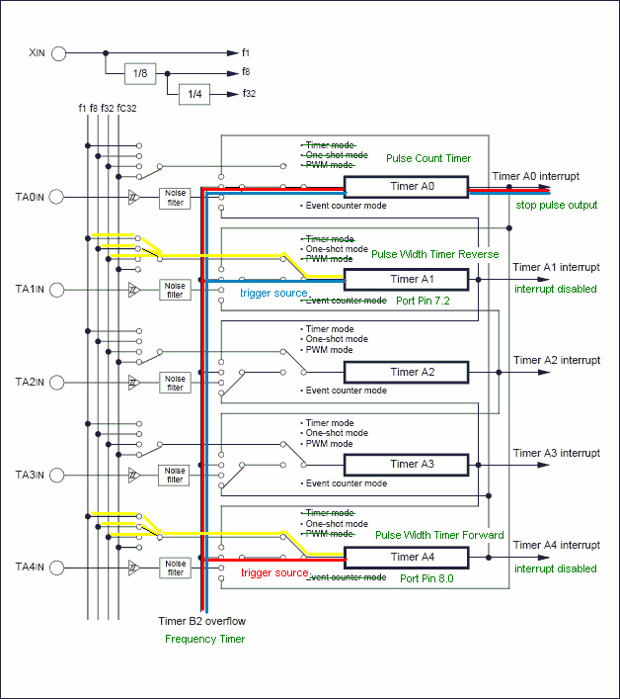

Pulse generation algorithm

The pulse generation algorithm was extended in several aspects:

- The timer hardware is reprogrammed for pulse generation only every 100 ms instead of the previous 190 μs – also reducing the interrupt load by the same amount
- Extended pulse addition count from 32 to 64 bits in order to increase the precision to compensate rounding errors for the update counts
- New calculation method of pulse generation timing to achieve a mark-space ratio of 1:1 for all possible pulse width settings (0,09 ms – 2000 ms)

The coordinator will cyclically (every 100 ms) call the UpdateEXE method of the digital output subsystem in order to pass the most recent flow rate. From this flow rate a 64 bit addition count will be calculated which is further processed in the UpdatePulseOutput function. From this addition count and two further 64 bit accumulators (for forward and reverse flow) the number of pulses to be generated will be calculated. Following that, the method SetDigitalOutputPulses will be called and reprogram the timers to generate the desired number of pulses for pulse widths until 50ms. For pulse widths larger than 50ms the method SetDigitalOutputLongPulse will be called.
In addition to that the total time for generating the complete pulse packet will be calculated. In case the time to output the pulses is longer than 100 ms window, a gap time will be derived that is used to add a delay for the pulse generation of the following window. This method ensures that the mark-space ratio of 1:1 is always preserved.

Gap [ms]
100
200
300
400
0
Time [ms]
40
40
Digital Out Signal (40 ms pulse width, 100% flow)
Voltage
0
60
40
20
0

Parameter configuration algorithm for Pulse Output

The current implementation of the digital output subsystem allows the user to configure the following parameters that influence the behaviour of the pulse output:

- Maximum flow value Qmax
- Unit of the Totalizer
- Pulse factor (pulses per flow volume in pulse mode 1)
- Full scale frequency (frequency for Qmax flow in pulse mode 2)
- Pulse width (length of the pulse in milliseconds)
- Limit frequency (upper frequency limit for pulse output)
- Simulation frequency (frequency used for digital output test)

In the following scheme a parameter change leads to a recalculation of the associated parameter ranges from top to bottom. If one of the associated parameters is now out of its range, the actual value is adjusted to the closest value inside the range and an alarm is generated to indicate the automatic parameter update to the user.

Figure 8: Range and value update dependencies after parameter change
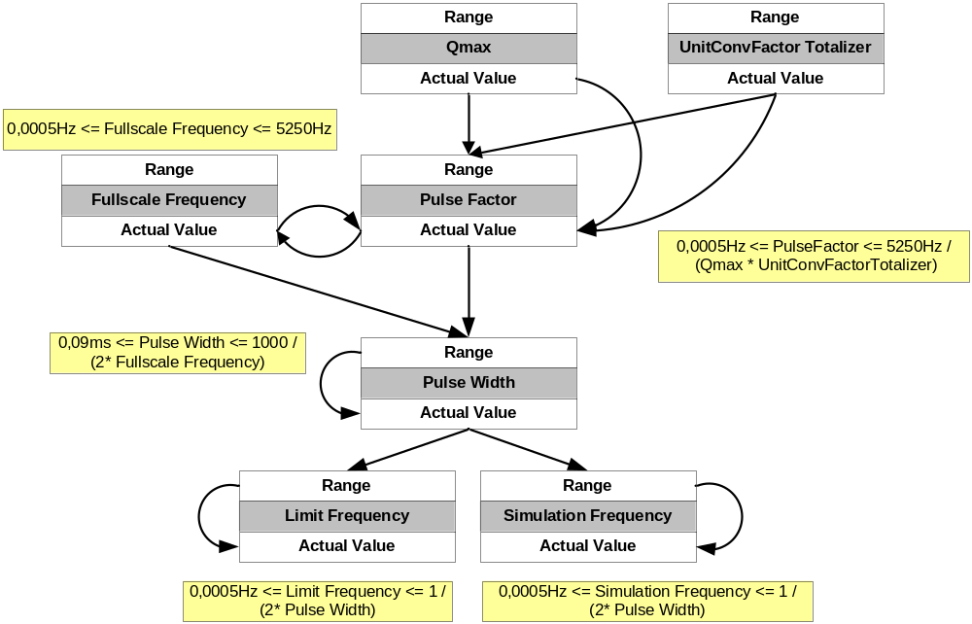

Figure 9: Parameter configuration by performed actions
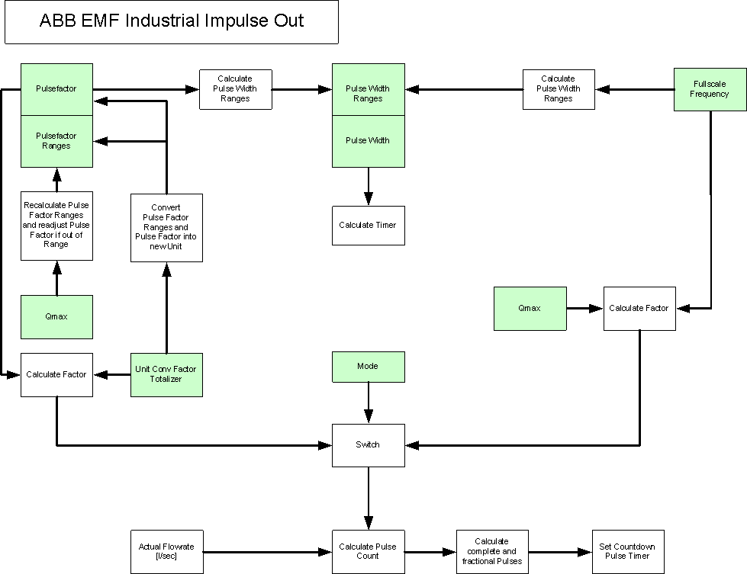

Design Decisions and Limitations

The Digital Output Subsystem is designed for use with the ABB BUI Common Framework running with Segger embOS operating system [5]. Update times for this system are not specifically mentioned in the original Common Requirements Specification.

Variant Handling

Two variants of the software (IND, WW) will allow for deployment in either the Industrial or Water Waste target. Both will have the same memory usage.

Pulse Operation Selection

A selectable parameter, Pulse Operation, has been introduced to allow the user to define the output mode in terms of pulses per volume unit (pulse-factor) or a frequency corresponding to 100% flow (“fullscale” frequency). These modes are referred to as “Pulse Mode 1” and “Pulse Mode 2”, respectively.

Because the pulse operation mode implies utilization of different parameters (either pulse-factor or fullscale frequency) the opposite parameter is always calculated following a setting change (including unit change). For example:
1. In Pulse Mode 1, a user adjusts the pulse-factor required; when changed, the fullscale frequency is automatically updated and can be read by HART and HMI.
2. In Pulse Mode 2, a user adjusts the fullscale frequency; when changed, the pulse-factor is automatically calculated at the correct value corresponding to the user-set fullscale frequency.

Pulse Output Units-of-Measure Conversion Factors

In Pulse-Mode 1, in order to accommodate selectable units-of-totalizer in respect of pulses output, the received flow value is multiplied by a uot-conversion factor, provided by an external subsystem, as a single precision floating-point value.

The Digital Output subsystem must provide methods for an external subsystem to call, in order for the latter to indicate as-and-when a change of units is being requested. The Digital Output subsystem uses this as an instruction for it to request the required conversion factors of the external subsystem.

Limit Frequency Dynamic Limits

Within the subsystem configuration, the limit frequency value limits are to be handled differently from all other configuration parameters, which are subject to fixed low and high limits.

A description of the factors affecting limit frequency is given in the Digital Output Subsystem Requirements Specification [3]. Methods are to be provided to accommodate the different limiting behaviour required to achieve this. The interpretation should be:

Limit Frequency is to be dynamically limited according to the following:

limitFrequency (HiLim) <= (0.5 x 1 / (pulseWidth) x 1000 ms) Hz subject to max limit of 5250 Hz
limitFrequency (LoLim) >= 0.005 Hz

Changes to the limit frequency will adhere to these limits. Changes to the pulseWidth that result in the limit frequency value exceeding the (re-) calculated dynamic limit should result in the limit frequency value being changed (set equal to the dynamically calculated (HiLim) limit).

Pulse Valid/Mode private attribute

A private attribute of the TPulseOutputData (pulseSignalValidtion::enum) is needed to cope with the scenario where no Digital Output is configured for pulses. In this scenario, the digital outputs’ configuration for pulseFlowSource (which indicates the volume/mass units of measure choice) would be “NoPulseFlowSource”.

In order to avoid having missing information in respect of pulse-calculations, the pulse-valid indication should be set to “invalid” to account for the above scenario.

In addition this should be bundled with a pulse-mode indication, to distinguish Normal and Simulation pulses. The reason for this is to handle the scenario if either digital output (OP1, OP2) is engaged in pulse-simulation. This setting would enable the simulation setting to override the normal operation, ie: pulse-simulation on one output and normal operation on the other cannot be catered for.

Hence, the private attribute: pulseSignalValidation::
TENUM {PULSE_OUTPUT_NOT_VALID, NORMAL_PULSES_VALID, SIMULATION_PULSES_VALID} would be of benefit to the design.

Logic Signal Valid private attribute

A private attribute of the TLogicOutputState (logicSignalValidation::enum) is needed to cope with the scenario where a Digital Output is configured for pulse outputs. In this scenario, the configuration for pulseFlowSource would be set to something other than “NoPulseFlowSource” rendering logicSignalSource, and logicActiveState, invalid.

Another scenario where this is also needed is for OP1 in the Industrial (IND) version. If the OP1 circuitType is set as “Active”, any logic settings are, again, rendered invalid.

In order to avoid having missing or conflicting information in respect of whether the logic-output needs setting, the logic-signal-valid indication should be set to “invalid” to account for the above scenarios.

Hardware Dependencies

The Digital Output subsystem has direct dependency on hardware. The requirement is to address 2 individual hardware ports directly as outputs (up to 2 logic, or 2 pulse, outputs), and also set the circuit type (passive/active) control port pin.

In respect of memory, the actual storage of settings and values to NV memory is looked after by a Common Framework compatible NV handler subsystem external to the Digital Output subsystem.

Revision Chart

Rev. | Description of Version/Changes | Primary Author(s) | Date
1.0 | Updated Version for the Industrial Digital Output | G. Horst | 2008-02-02

